Understanding the Rotation of the Milky Way
Using Radio Telescope Observations
Alexander L. Rudolph
Professor of Physics and Astronomy, Cal Poly Pomona
Professeur Invité, Université Pierre et Marie Curie (UPMC)

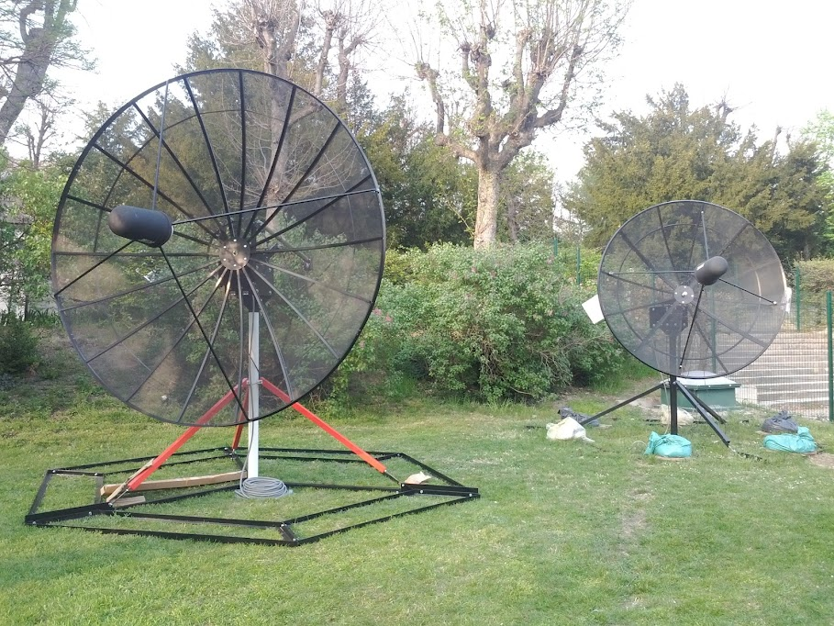

- Conceptual Challenges (Kinesthetic Activity)

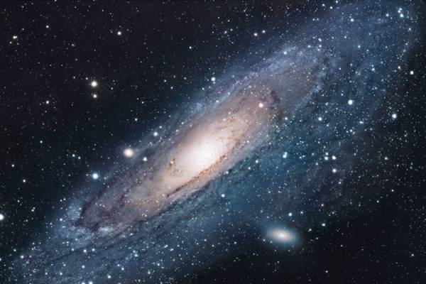
The main conceptual challenge to understanding how we can observe the rotation of the Milky Way galaxy (our home galaxy) is the fact that we reside inside the Galaxy. Thus, our observations of motions of objects in our Galaxy are made from a platform (the Solar System), which is itself moving relative to the Galaxy frame of reference.

To measure motions of objects in the Universe, we use the Doppler Shift, whereby the wavelength of light is shifted due to relative motion along the line of sight (radial motion) between the emitter and the observer, relative to what we would observe if the two were at rest relative to one another. For this exercise, we will assume that you are familiar with this effect. We simply note that when the relative motion is away (the distance between the emitter and observer is increasing, or positive velocity) then the light is redshifted, meaning it is shifted towards longer wavelengths, whereas when the relative motion is towards (the distance between the emitter and observer is decreasing or negative velocity) then the light is blueshifted, meaning it is shifted towards shorter wavelengths.
Figure 1. This image of the Andromeda galaxy, our nearest neighbor, shows what the Milky Way might look like if we could observe it from outside.

To help understand the kinematics (motions) of the Milky Way, we will begin with a kinesthetic learning activity, in which we will act out the rotation of our Galaxy. We will discover that there is a pattern to the observed motions of objects in our Galaxy from our vantage point in our Solar System. To measure the radial velocity (v_{r}) of objects relative to ourselves, the observer, we will use a Doppler detector, namely a length of bungee cord held taut between the observed object (the emitter) and the Sun (the observer). As the Galaxy rotates, if this cord stretches, then we know that the distance between the emitter and observer is increasing, indicating a redshift, and if the cord becomes slack (droops) then we know that the distance between the emitter and observer is decreasing, indicating a blueshift.

Let’s go act out Galaxy rotation!

- Modeling the Kinematics of the Milky Way
  - Comparisons with the kinesthetic activity

Let’s now review what we learned in our activity. We can define a coordinate system for observing objects in the Milky Way centered on our Solar System, in which Galactic longitude (l) is a measure of the direction of observation in the plane of the Galaxy, where l = 0 is the direction of the Galactic center. We can then define four quadrants, based on the value of l (see Figure 2 below):
Figure 2. Diagram showing the definition of Galactic longitude and the four quadrants. The sense of rotation is clockwise in this diagram.

As we noted in our activity, the sign (+ or −) of the Doppler shift depends on which quadrant we are observing. We observed that:

Quadrant I: 0° < l < 90° v_{r} > 0 (redshifted)
Quadrant II: 90° < l < 180° v_{r} < 0 (blueshifted)
Quadrant III: 180° < l < 270° v_{r} > 0 (redshifted)
Quadrant IV: 270° < l < 360° v_{r} < 0 (blueshifted)

To understand why this pattern exists, we need to understand mathematically how v_{r}, the radial velocity, is determined. Essentially, when we observe an object in our galaxy, we detect the relative motion of the object along our line-of-sight to the object.

To determine the magnitude of the relative motion, we can use the following diagram (Figure 3) below, where we have assumed circular rotation at constant speed, and where the following variables have been defined:

V₀ Sun’s velocity around the Galactic center (= 220 km/s)
R₀ Distance of the Sun to the Galactic center (= 8.5 kpc; 1 pc = 3.09 x 10¹⁶ m)
l Galactic longitude
V Velocity of a cloud of gas
R Cloud’s distance to the Galactic center, or Galactocentric radius
d Cloud’s distance to the Sun

Figure 3. Diagram for the rotation of the Milky Way

The key idea is that we need to find the projection of both V₀ and V onto the line of sight , and then take the difference.

To find the projection of V₀ onto the line of sight, we simply note that the angle c = l, so the projection of V₀ onto the line of sight is simply V₀ sin(l).

To find the projection of V onto the line-of-sight is a bit trickier. First we note that this projection can be written V cos(α). To relate α to l, we see that, since CM and CT MT, the angle a = α, so that cos (α) = cos (a) = CT/R.

Finally, we note that from triangle SCT, we can see that sin(l) = CT/R₀, so finally, with a little algebra, we get that the projection of V onto the line-of-sight is (R₀/R) sin(l).

Taking the difference between these two terms gives us our final result for the observed Doppler shift v_{r}:

To find our result for the sign of this term as a function of Galactic longitude l, we will make a simplifying assumption that V = V₀, which we will discover is true for R > 2-4 kpc. In that case we find:
Using the table below, fill in the sign (+ or −) of each of these terms, and multiply the find the sign (+ or −) of v_{r} for each quadrant. Work in groups and compare your answers with your neighbors. If you do not agree, make sure you discuss your results until you do. Do your results agree with what we found in our kinesthetic activity?

Table 1
 |  |  | V₀ | sin(l) | (R₀/R)−1 | v_{r}
Quadrant I | 0° < l < 90° | R < R₀ | +
Quadrant II | 90° < l < 180° | R > R₀ | +
Quadrant III | 180° < l < 270° | R > R₀ | +
Quadrant IV | 270° < l < 360° | R < R₀ | +

  - The rotation curve of the Galaxy

We can now turn our attention to determining the rotation curve of the Galaxy, namely a plot of V v. R. To create this curve, we need to use our observations of v_{r}, and a little clever reasoning. Let’s go back to our equation for v_{r}:
Along a given line-of-sight, the value of v_{r} will be a maximum when R is a minimum, as long as V increases monotonically (steadily) with R, which it does. Thus, if we observe a number of objects (e.g., gas clouds emitting 21-cm radio radiation) along the same line-of-sight, the one located at the smallest Galactocentric radius (R), will have the largest v_{r}. Figure 4 illustrates this point.

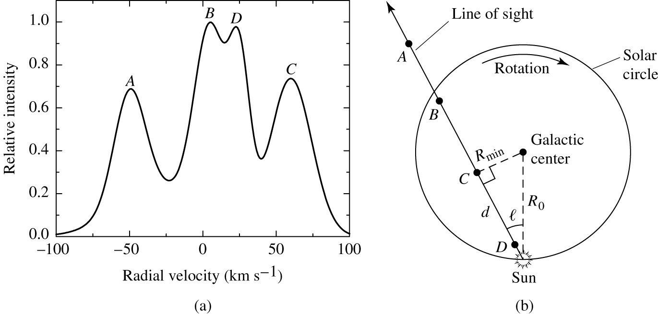
Figure 4. (a) Plot of Hydrogen 21-cm emission along a line-of -sight from the Sun. (b) A diagram showing the positions of the 4 Hydrogen clouds (A,B,C,D) relative to the Sun. Note that the cloud with the smallest R (cloud C) has the largest radial velocity

From Figure 4, we see that cloud C has the largest radial velocity, v_{r} ≈ 65 km/s, and is at a longitude of l ≈ 30°.

To find V, we know everything except the location of the cloud, namely its Galactocentric radius, R. To find R we note that the smallest radius along the line-of-sight, R_{min}, is at a tangent point, so we can easily determine, from simple trigonometry of right triangles, that R = R_{min} = R₀ sin(l). Substituting into our equation for v_{r}, this simplifies to become:
Thus, for cloud C, we find:

Note that this method, known as the tangent-point method, only works for Quadrants I and IV, namely the inner Galaxy (R < R₀).

Use the tangent-point method to determine R and V for clouds at the following longitudes and radial velocities in the table below. Recall that R₀ = 8.5 kpc, and V₀ = 220 km/s. Work in groups and compare your answers with your neighbors. If you do not agree, make sure you discuss your results until you do.
Table 2
l | v_{r} (km/s) | R (kpc) | V (km/s)
15° | 140
30° | 100
45° | 60
60° | 30
75° | 0

  - Radio observations to determine the Galactic rotation curve

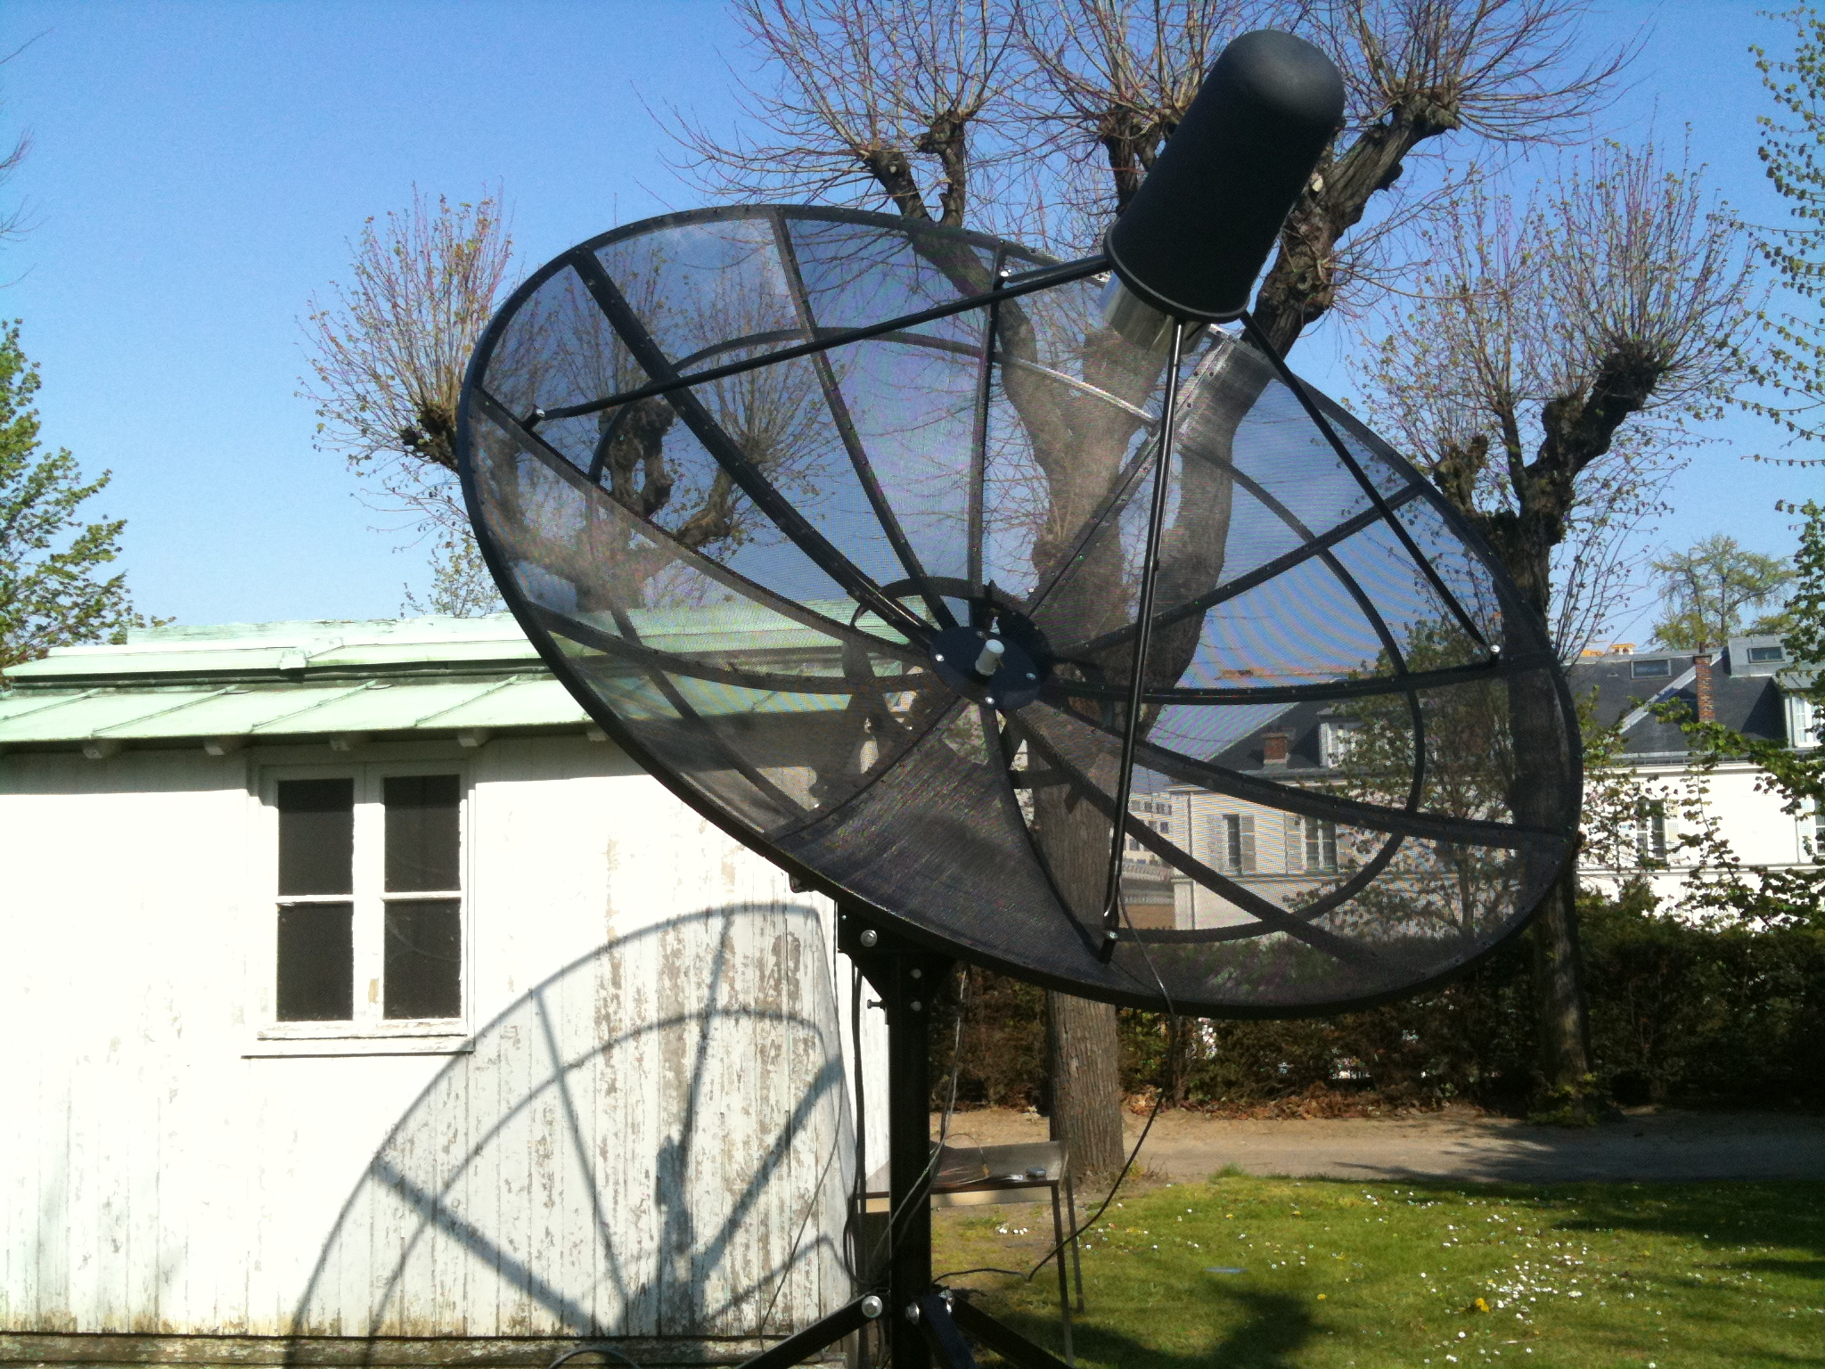
We will now simulate real radio telescope observations of 21-cm line radiation from cloud of hydrogen gas in our Galaxy. The possibility exists to make your own real observations of this gas using one of a number of remote-controlled telescopes operated by EU-HOU, and available for public use. You will each have a chance to use this telescope to make observations during the day.

To simulate observations of hydrogen clouds in our Galaxy, open the EUHOU radio telescope simulator at: http://euhou.obspm.fr/public/simu.php. You will see a screen like the one below.

The screen in the upper left shows a color-encoded map in Galactic coordinates of 21-cm hydrogen emission taken from the Leiden/Argentine/Bonn (LAB) Galactic HI Survey (Kalberla, P.M.W. et al. 2005). The colors represent intensity, where red is the most intense and blue is the least intense. The red stripe across the screen is the plane of the Galaxy. By placing the cursor over this map, it is possible to simulate observed spectra of various lines-of-sight in our Galaxy, which will appear in the lower lefthand screen. Before beginning, make sure that the “Visibility” box above the HI Galaxy map is unchecked. Otherwise, you will be restricted to “observing” only what is visible to the selected EUHOU radio telescope.

- One by one, move the mouse over each of the longitudes for which you calculated R and V, and click. Each time you click the mouse, a circle will appear on the map, and the longitude and latitude of that circle will appear in the boxes (labeled Lon. and Lat. to the right). Put the mouse as close to the Galactic plane (Galactic latitude = 0) as you can. Keep clicking and moving the cursor until you have the longitude and latitude you want (e.g., longitude = 15°, latitude = 0°).

- Once you have the values you want, click the “Simulate” button and a spectrum will appear in the lower left hand box. Move the cursor into that box and crosshairs will appear. The values below the box, “V = ” and “T = ” represent the velocity and “temperature” (corresponding to the intensity of the radiation at that velocity measured in radio astronomy units) of that cursor position.

- Move the cursor over the peak with the largest velocity (furthest to the right on the screen), and click the mouse. A vertical blue line will appear at the velocity you have chosen. Note if the value of the velocity matches the one that appears in Table 2. You can also find the velocity of the other peaks in the spectrum the same way. These represent other clouds along the same line-of-sight.

- Once you have finished labeling peaks in the spectrum, click the “send max” button underneath the screen. A point will appear in the plot of V versus R to the right. By moving the cursor over the point that appears, you can check if the values for that longitude match those you found in Table 2. If not, go back and check your work!

- Once you have found (and checked) R and V for the 5 longitudes in Table 2, you can use the simulator to find values for any longitude you like in Quadrant I. (If you try to “send max” for a point in Quadrants II or III, nothing will appear in the Galactic rotation plot to the right, since the tangent-point method only works in the Inner Galaxy, R < R₀; Quadrant IV should work but has not been implemented yet in the software).

- Congratulations, you have measured the rotation curve of the Milky Way galaxy!

  - Measuring the mass of the Milky Way galaxy

The rotation curve of a galaxy can be used to determine the mass of the galaxy using some very simple Newtonian physics. For this calculation, we will assume that the mass of the galaxy is spherically symmetric. While the stars (and gas clouds) of spiral galaxies are found in a flattened disk, this approximation is acceptable for two reasons:

- The difference between the result for a spherical distribution of mass and a flattened disk of mass is a factor of only a few, so the result will be the correct order of magnitude

- More importantly, we will soon discover that the majority of the mass of the Milky Way galaxy is in a spherically symmetric halo of dark matter, unseen mass that is affecting the dynamics (and therefore the kinematics) of the Galaxy

Imagine a star or gas cloud, of mass m, orbiting the Galaxy at Galactocentric radius R. Newton’s Law of Gravitation says that the gravitational force on this object is

where M(<R) is the total mass interior to R, and G is Newton’s universal gravitational constant. Combining this result with Newton’s 2nd law, we get

where a_{c} is the centripetal acceleration of circular motion. Solving this equation for M(<R) gives

Thus, by measuring V for a given R, we can find the mass of the Galaxy interior to that point. Clearly, the further out from the center we can measure the velocity of objects, the better estimate of the mass we can obtain.

- Use the values from Table 2 corresponding to the largest R to determine the mass of the Galaxy (in solar mass units, M = 2 x 10³⁰ kg) interior to that radius. Be careful with your units. Convert everything to SI units (G = 6.67 x 10⁻¹¹ uSI, and 1 pc = 3.09 x 10¹⁶ m, so 1 kpc = 3.09 x 10¹⁹ m), to find the mass in kg, then divide by the mass of the Sun (M = 2 x 10³⁰ kg) to find the answer in units of M. This is only the mass interior to the Sun.

- Using the Galactic rotation curve below (Figure 5), find the mass of the Galaxy interior to the largest radius you can measure from the curve (about 17 kpc).

Figure 5. Galactic Rotation Curve (Brand and Blitz 1993)
- Measurements of the velocities of dwarf galaxies (including the Magellanic Clouds) orbiting the Milky Way galaxy (see Figure 6) can give the best possible estimate of the total mass of the Galaxy. Measurements of the velocities of the Magellanic Clouds and the dwarf spheroidal galaxies in Sculptor and Ursa Minor, reveal motions of V ≈ 175 km/s at Galactocentric radii of R = 100 kpc (Bell and Levine 1997). Using these values, find the total mass of the Milky Way galaxy. How does that value compare to the mass of stars in the Milky Way of about 2 x 10¹¹ M? The difference between these values is attributed to dark matter (Figure 7).

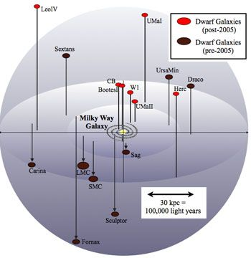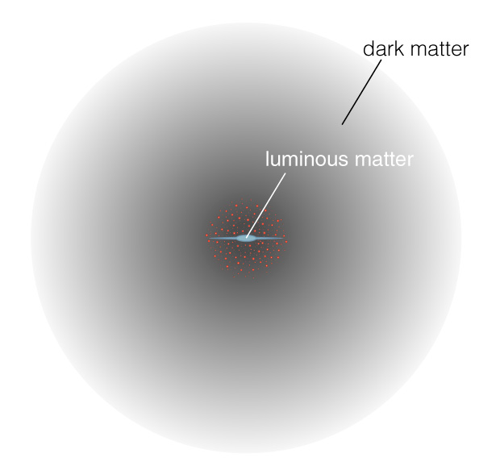
Figure 6. Milky Way environment Figure 7. Artist’s conception of the dark matter halo around the Milky Way galaxy

References

Bell, G. R., and Levine, S. E., 1997, BAAS, 29 (2): 1384

Brand J., Blitz L., 1993, A&A, 275, 67

Kalberla, P.M.W. et al., 2005, A&A, 440, 775

"This project has been funded with support from the European Commission. This publication reflects the views only of the author, and the Commission cannot be held responsible for any use which may be made of the information contained therein."

